2.4 Habitat Restoration
Activity Title | Date | Description (1-2 Sentences) | Metrics
Greenhouse and surrounding garden beds- MD natives | 2021-2022 SY  2022-2023 SY | Each year, the greenhouse serves as a nursery for native Maryland annuals and perennials to plant in Towson High School’s memorial garden. The THS Environmental Club and community are involved in garden planning, plant selection, and plant care. Throughout the process, the community partakes in educational activities, such as pollinator identification about both native plants and invasive species.  The borders of the greenhouse also house native perennials and annuals. While contributing to the campus landscape, the diversity of plants around the greenhouse attracts pollinators and birds, which can be observed for educational purposes. The Environmental Club and Towson community are involved every step of the way, from planning to planting. The greenhouse border plants include daffodils, bearded irises, butterfly flowers, and swamp milkweeds, among others.  Evidence below shows school yard clean ups to get ready and the natives purchased from Herring Run nursery
Memorial Garden | Spring 2022 | The Towson High School memorial garden (dedicated in the 1980s), is the school’s main native garden, located between the lacrosse and softball fields. In 2022, the Environmental Club planned, fundraised, and planted a new group of native perennials. These include aster, common milkweed, black-eyed Susan, and goldenrod. The memorial garden is used by the school community for instruction about the benefits and properties of native species and pollinators.  Pictures below show the planting of the memorial garden  Link to Planning PowerPoint:  2022 Native Garden polls and plans.pptx

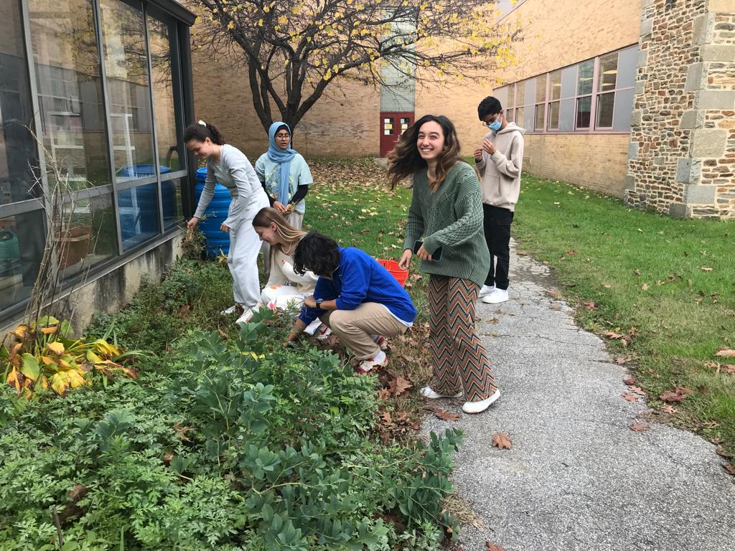
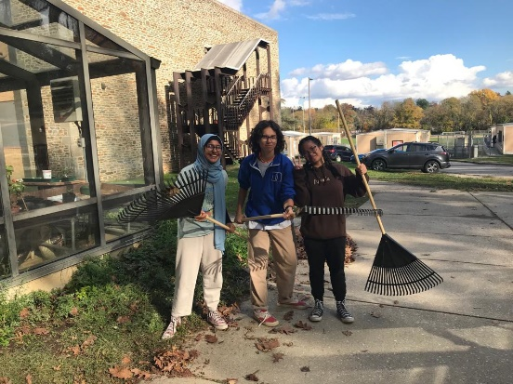
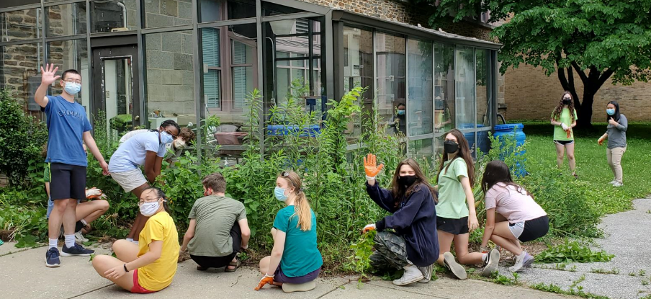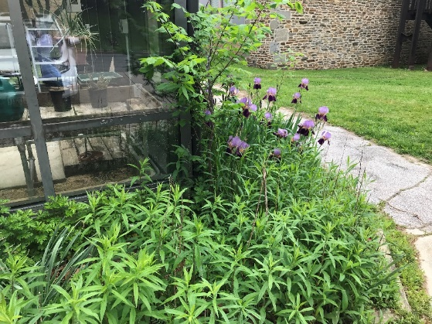
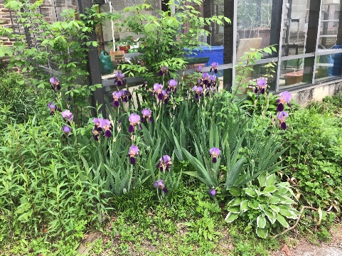
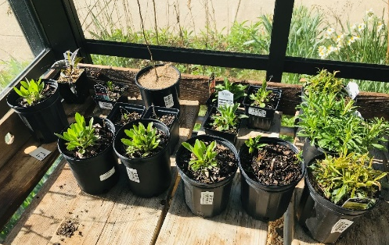
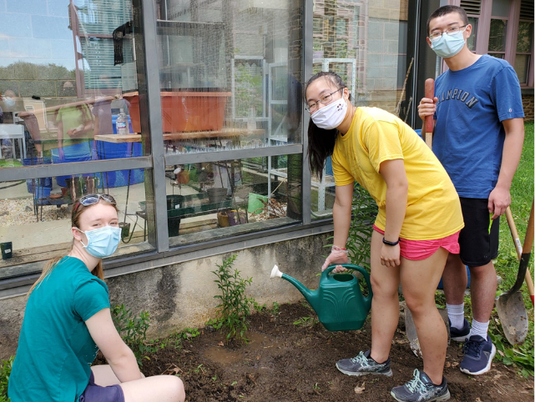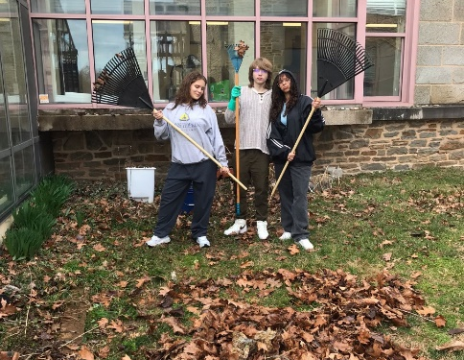
GREENHOUSE AND NATIVE GARDENS
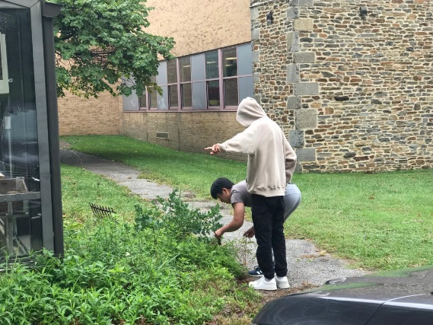
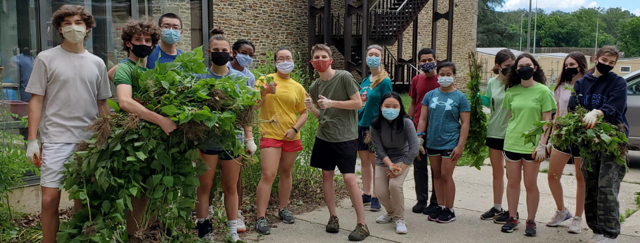
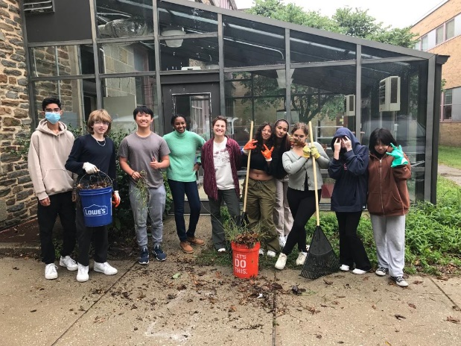
GREENHOUSE AND NATIVE GARDENS

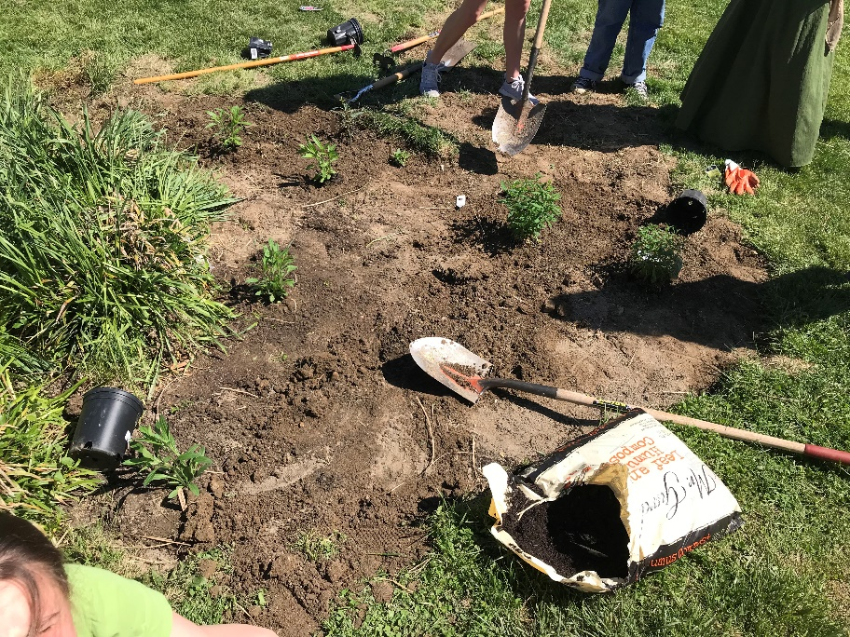
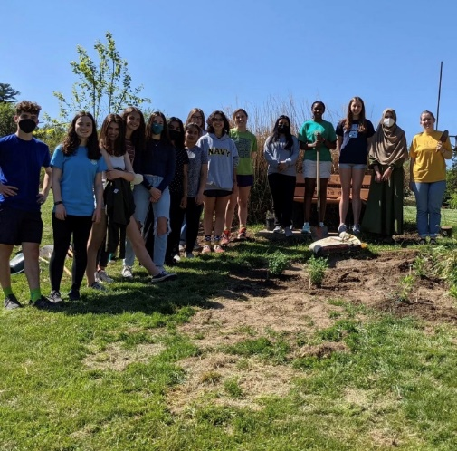
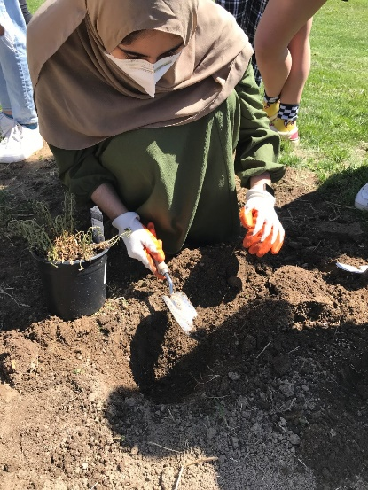
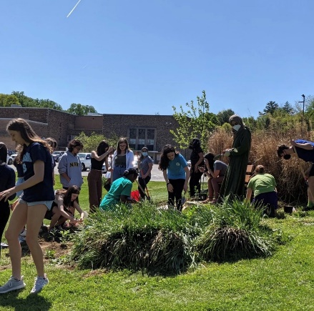
v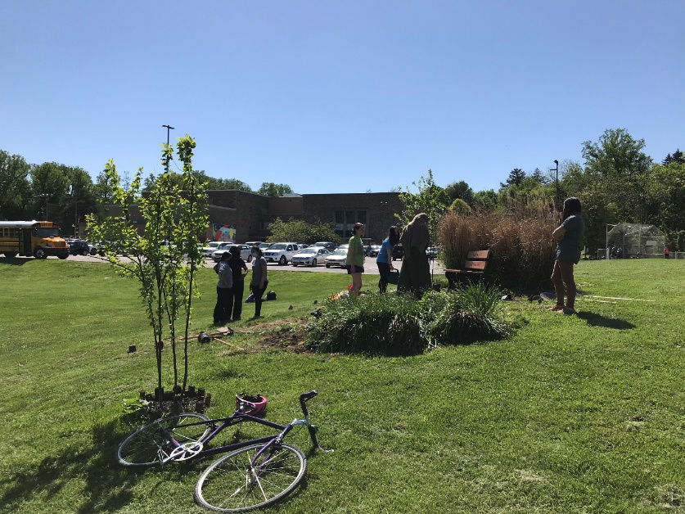
Students planting native Maryland perennials in the Memorial Garden

